There are n servers numbered from 0 to n-1 connected by undirected server-to-server connections forming a network where connections[i] = [a, b] represents a connection between servers a and b. Any server can reach any other server directly or indirectly through the network.

A *critical connection* is a connection that, if removed, will make some server unable to reach some other server.

Return all critical connections in the network in any order.

**Example 1:**

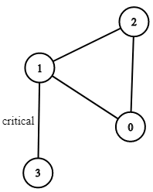

**Input:** n = 4, connections = [[0,1],[1,2],[2,0],[1,3]]

**Output:** [[1,3]]

**Explanation:** [[3,1]] is also accepted.

**Constraints:**

* 1 <= n <= 10^5
* n-1 <= connections.length <= 10^5
* connections[i][0] != connections[i][1]
* There are no repeated connections.